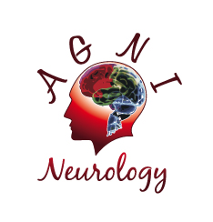
NEUROLOGISTS REQUIRED FOR BUSY SYDNEY PRACTICES
AGNI Neurology has rooms in ROZELLE and HORNSBY
A unique opportunity exists for an enthusiastic Neurologist to join a well-established practice with a strong referral base and a very long waiting list. Our Principal neurologist and Medical Director is considering retirement, so this is an excellent to take over the practice in the very near future.
The practice would suit a general neurologist, but an interest in Headache and Movement disorders would be preferable. Nerve conduction studies can be performed on site. EEG and MRI can be accessed at nearby locations.
We offer all administrative support, practice management and dictation of letters.
Remuneration is on a fee percentage basis.
Contact Arun Aggarwal agnish@bigpond.com

